ISCG7420 Web Application Development

Assignment 1

Name: Yishan Luo

ID: 1445181

Lecturer: Xiaosong Li

Table of Contents

Introduction 3

Business Specification 3

Customer 3

Administor 5

User Interface Design 8

Site Map 8

Actual Design 8

Database Design 19

Relationships 23

ER Diagram 24

Technique 25

Test Cases 25

Any User/New Customer 25

Registered Customer 26

Admin 27

# Introduction

Quality Cap is a simple web application (online purchase order system) which is used to sell caps. There are different categories such as men, women and children’s. This website has its front end which can be viewed and used by normal users as well as its back end, which can be managed by the admin of the website. This application was developed using Visual Studio 2015 with programming languages; ASP.NET MVC, C# and Microsoft SQL server for its database. Some other useful information:

* **URL**: <http://dochyper.unitec.ac.nz/luoy15/asp_application1/>
* **Admin Username**: Admin
* **Admin Password**: Admin1
* **Customer Username**: Customer
* **Customer Password**: Customer
* **Source Code**: [http://dochyper.unitec.ac.nz/luoy15/asp_assignment/assignment1_SourceCode.zip](http://dochyper.unitec.ac.nz/luoy15/asp_assignment/assignment1_SourceCode.zip%20)

# Business Specification

Business specification can be divided into two roles; customer and administrator. There are some other rules that do not pertain to those but belongs to the system itself;

* A logo is provided to the website which when clicked, redirects the user to the home page.
* Data validation are provided on pages like register, login and so on to check if the user inputs the correct information.
* If there is an error, a web designed error page will appear.

## Customer

There are two types of user;

* New customer/any user – login is not required.
* Registered customer – already registered user; can login.

The business rules for Quality cap for any user or customer is shown below:



*Business rules for any user/customer*

### Any Visitor/New Customer

Any user can freely browse the website, viewing all the Caps available.

Any user can search name for Caps using the search box provided on the website.

Any user can find contact information through the contact us page.

Any user can add a Caps to cart from cap list (cannot choose color) or cap detail (can choose color), but cannot checkout (login required).

A new customer can register by going to the registration page and filling the form – an email will be sent as confirmation.

### Registered Customer

A registered customer can freely browse the website, viewing all the Caps available.

A registered customer can search name for Caps using the search box provided on the website.

A registered customer can find contact information through the contact us page.

A registered customer can add a Caps to cart from cap list (cannot choose color) or cap detail (can choose color).

A registered customer can login by using the login page – username and password should be entered.

A registered customer can check out after successful login.

A registered customer can make an order after filling check out information (address, name and so on).

A registered customer can view order after successful checking out.

A registered customer can log out from the log out link at the top.

## Administrator

Business rule for administrator is shown below. The business specification can be divided into eight parts; login, log out, manage suppliers, manage categories, manage Caps, manage customer details and administrator can use all function as a registered customer.



*Business rule for Administrator*

### Login

The admin of Quality Caps is provided with username and password:

Username: Admin

Password: Admin1

The admin can use the back-end system after successful login.

### Log out

After the admin is logged in into the back end system, he/she will be able to log out by clicking the log out link.

### Suppliers Details

Admin can view all suppliers in a list.

Admin can view a supplier details by clicking detail link at the right side.

Admin can edit any supplier record by clicking edit link at the right side.

Admin can create a new supplier record.

Admin can delete a supplier record. However, if a record is being used by any Caps, the supplier will be deleted, but the caps will also be deleted.

### Categories

Admin can view all categories in a list.

Admin can view a category details by clicking detail link at the right side.

Admin can edit any categories record by clicking edit link at the right side.

Admin can create a new category.

Admin can delete a category record. However, if a category is being used by any Caps, the category will be deleted, but the caps will also be deleted.

### Color

Admin can view all colors in a list.

Admin can view a color details by clicking detail link at the right side.

Admin can edit any color record by clicking edit link at the right side.

Admin can create a new color.

Admin can delete a color by clicking delete link at the right side. If the color be deleted, customers cannot choose the color any more.

### Caps

Admin can view all caps in a list.

Admin can view a cap details by clicking detail link at the right side.

Admin can edit any caps record by clicking edit link at the right side.

Admin can create a new cap record.

Admin can delete a Cap record. However, if a Cap has been ordered, the Cap will be deleted, but the cap information in order detail will also be deleted.

### Customer Details

Admin can view all customers in a list.

Admin can view a customer details by clicking detail link at the right side.

Admin can edit customer records by clicking edit link at the right side.

Admin can create a new customer record.

Admin can disable a customer account by editing the customer information. Admin can unselect the IsAvailable check box on edit page, then save the information. Once the action has been done. The account will not be able to log in.

### Order Details

Admin can view all orders in a list.

Admin can view a customer details by clicking detail link at the right side.

Admin can edit order records by clicking edit link at the right side.

Admin can change the status of orders from ‘waiting’ to ‘shipped’ or from ‘shipped’ to ‘waiting’.

# User Interface Design

## Site map:



## Actual Design:

### Header



### Footer



The basic idea of the website is that it will have a navigation menu on top, at the left of it will be the logo, login and shopping cart link at the right. The middle portion of the website will be reserve for the content and at the bottom of the website will be its footer. The website will take to whole width and height of the screen or browser.

### Home Page



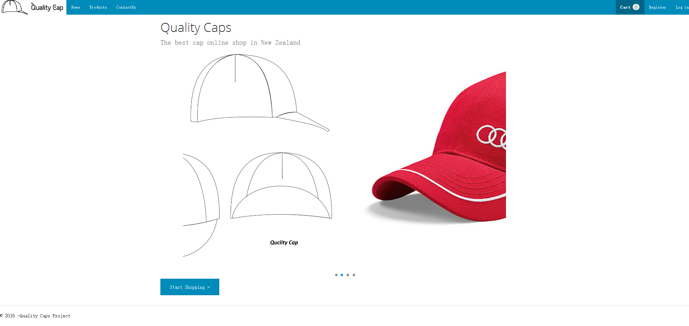

### Caps Page

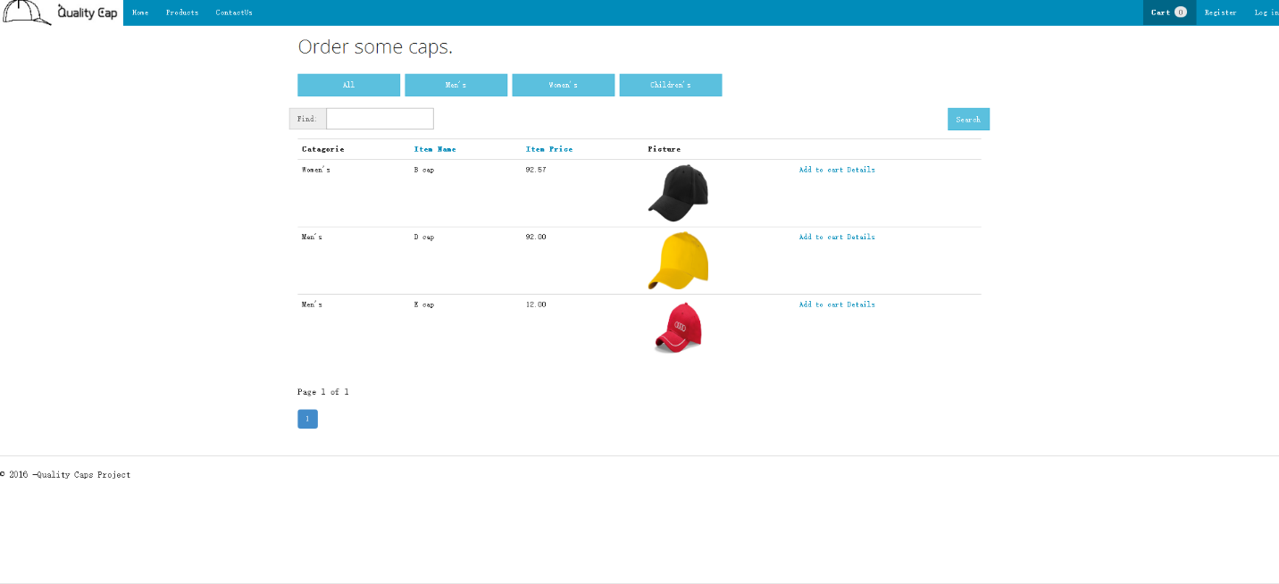

On this page, user can add cap into shopping cart, but will not be able to select color of the cap.

### Caps Detail Page



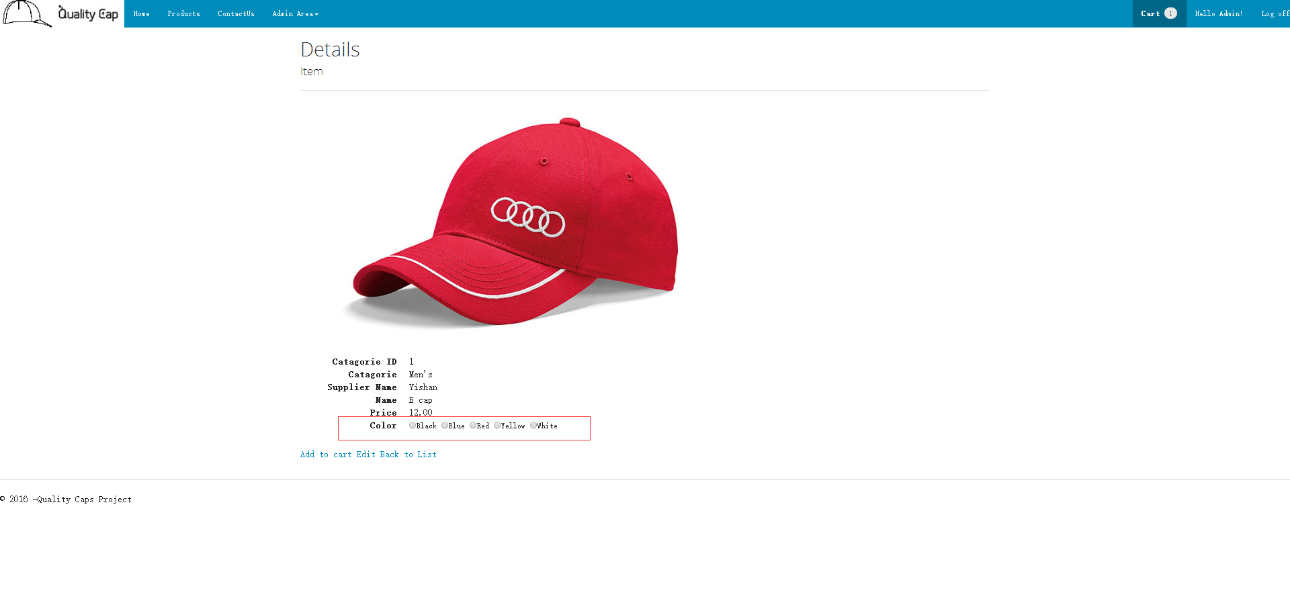

Customers can select color on this page and add cap to cart.

### Contact Us Page



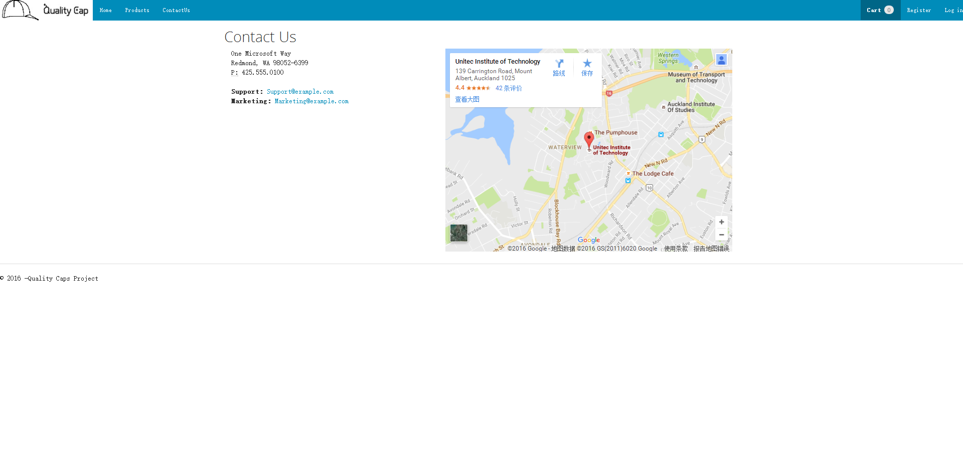

### Login Page



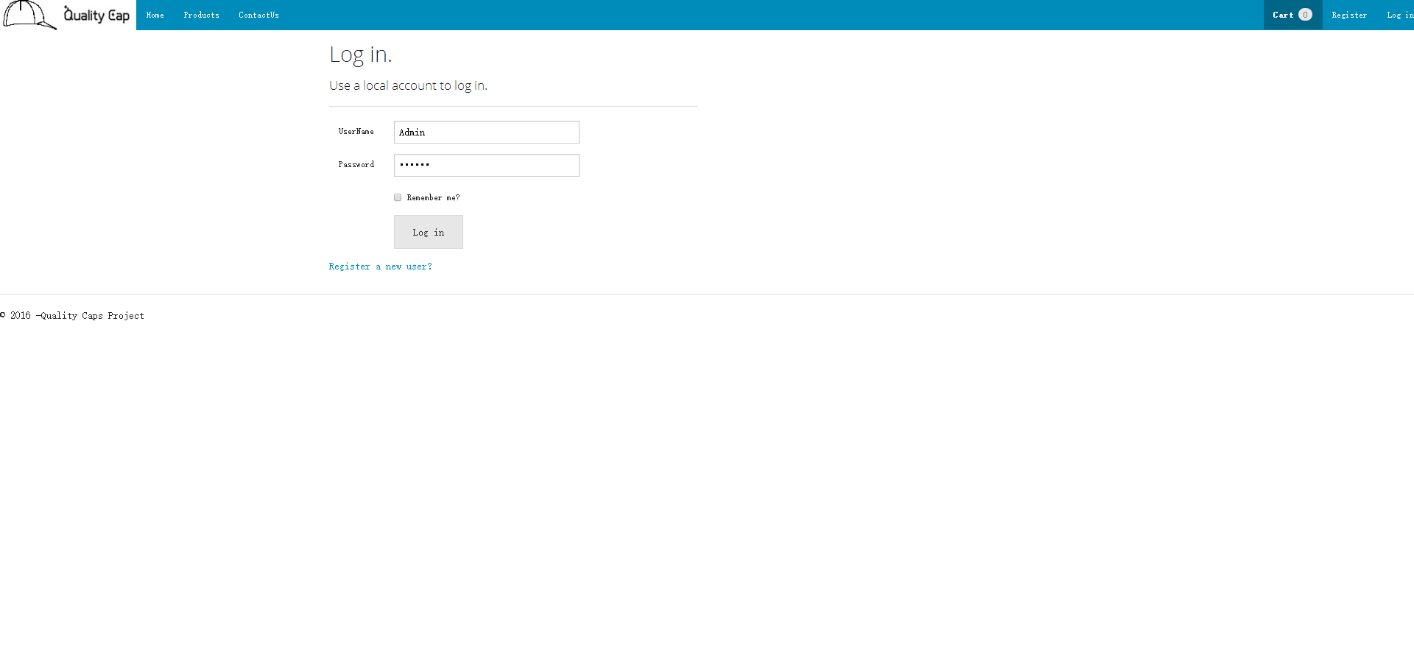

### Register Page



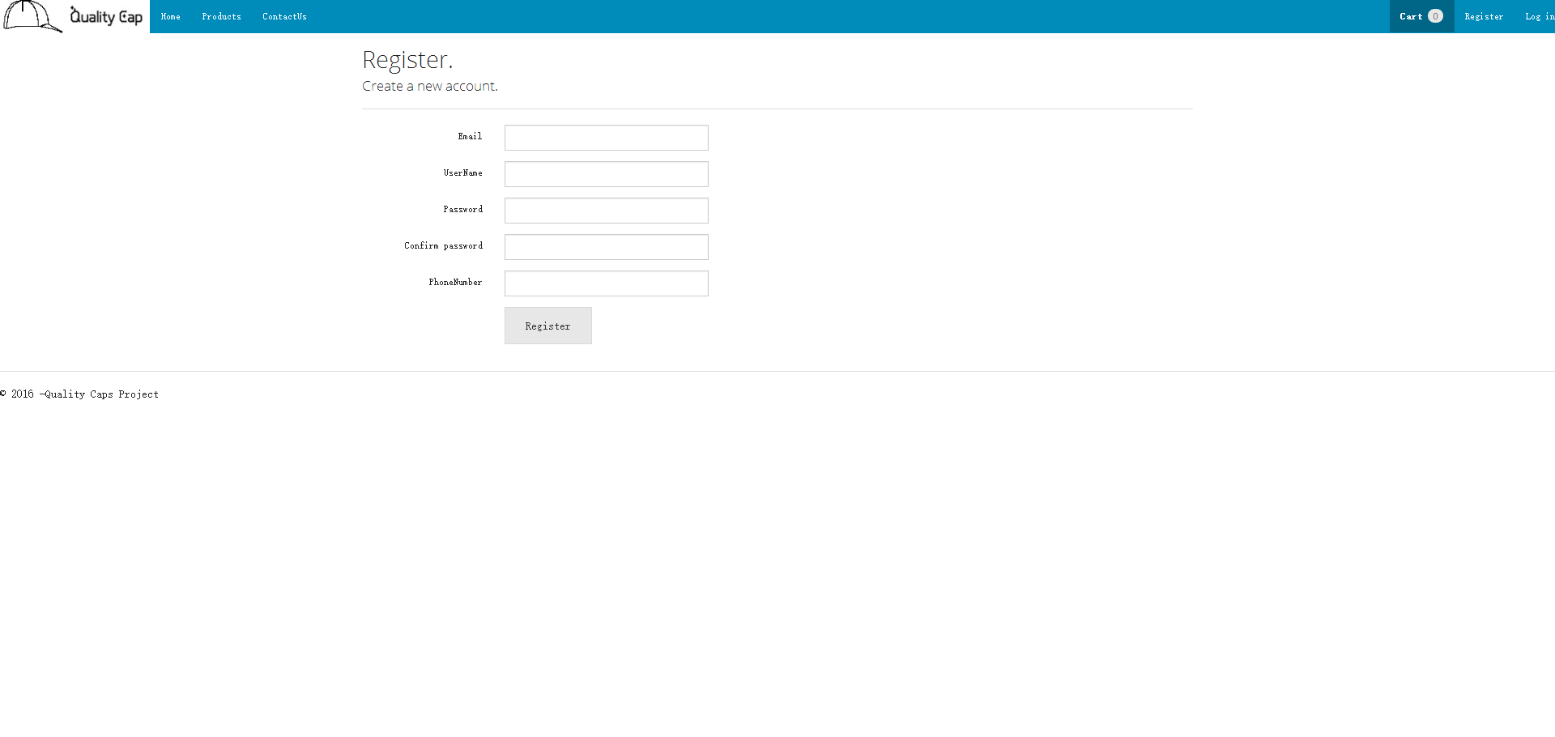

### Order Page



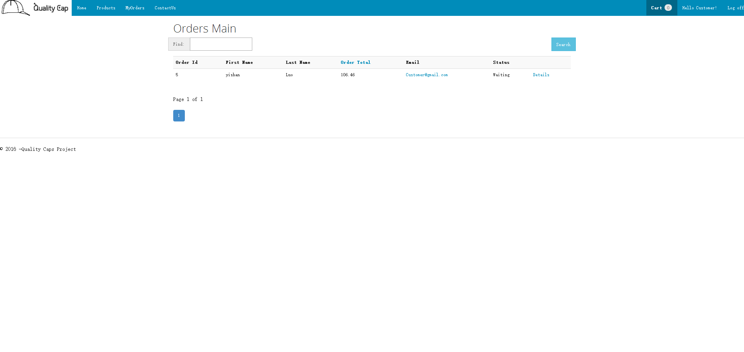

### Order Detail Page



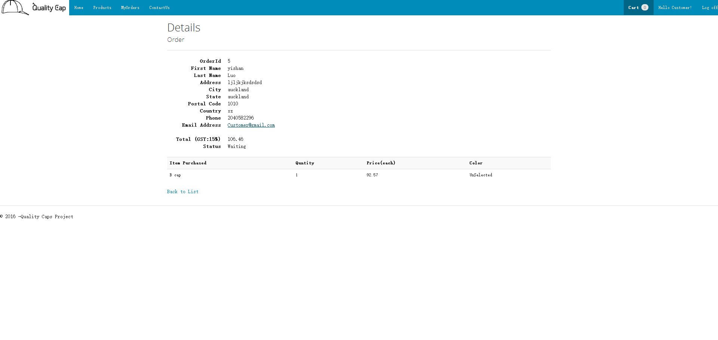

### Shopping Cart Page



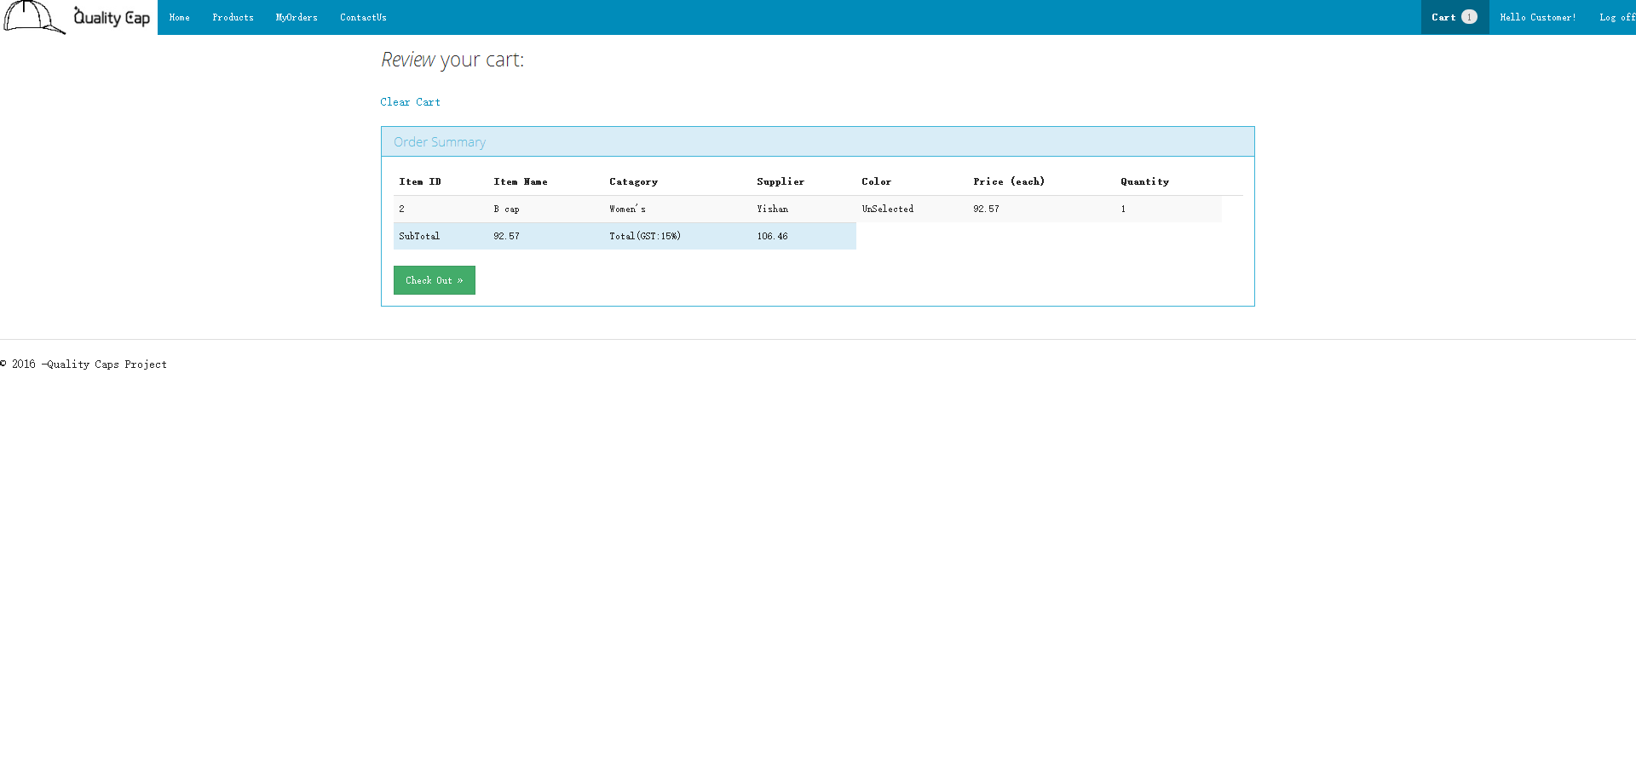

The website has to following navigation links; login, register, shopping cart, product, contact us. Once a user register, he/she will be able to login. After login, the register link will become manager account link and display “Hello” + username. The user will be able to either log out, view account/order or check out with Caps in cart.

Before login:



After login



## Admin Area

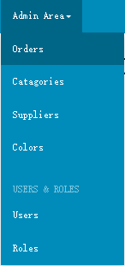

If use an admin account to login, then can see there is a dropdown list at navigation bar, which contents all manage pages.

The admin area includes the following links; suppliers, Orders, Categories, Color, Users, Roles. The admin can perform create, edit and delete according to specific pages (refer to site map). Admin can manage cap on Products page.

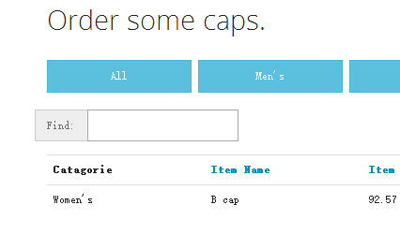Visitor:

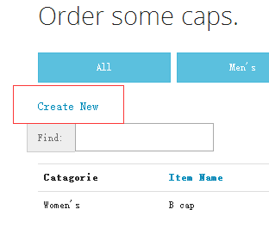Admin:

Meanwhile, admin user can see Edit link and Delete link at the right side.

Customer:

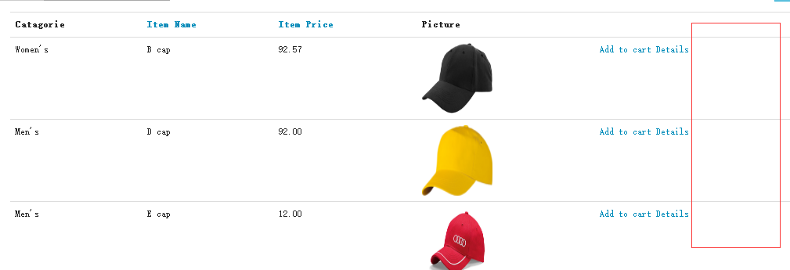

Admin: 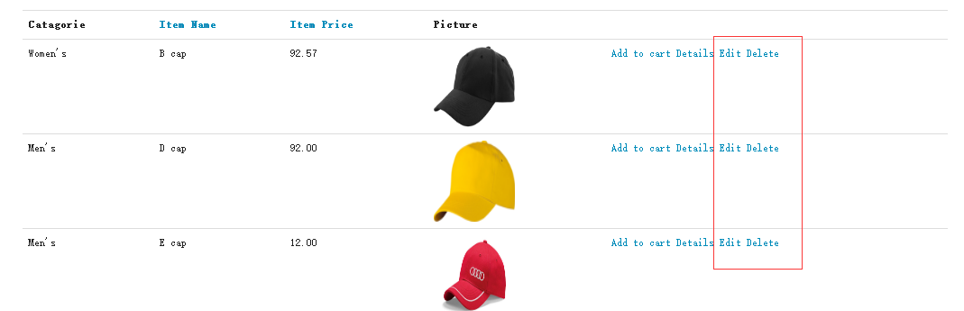

# Database Design

Entity Framework is used to generate database, models are shown below:

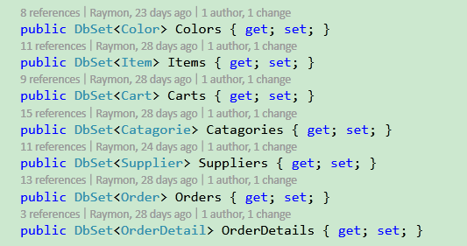

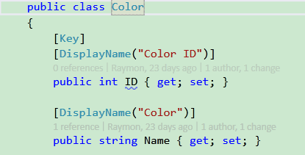

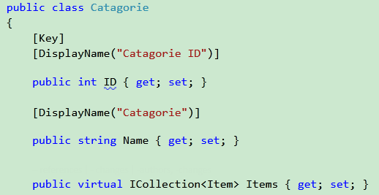

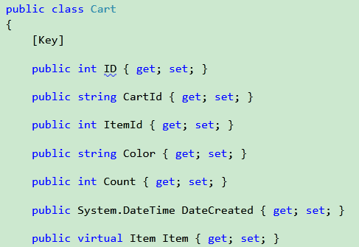

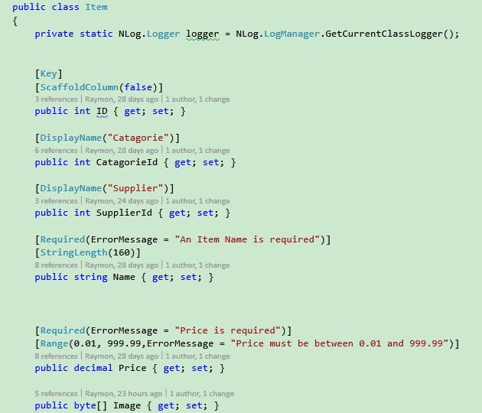

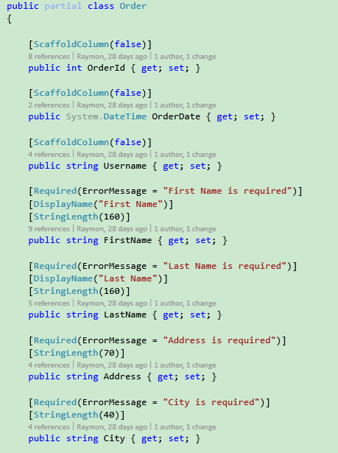

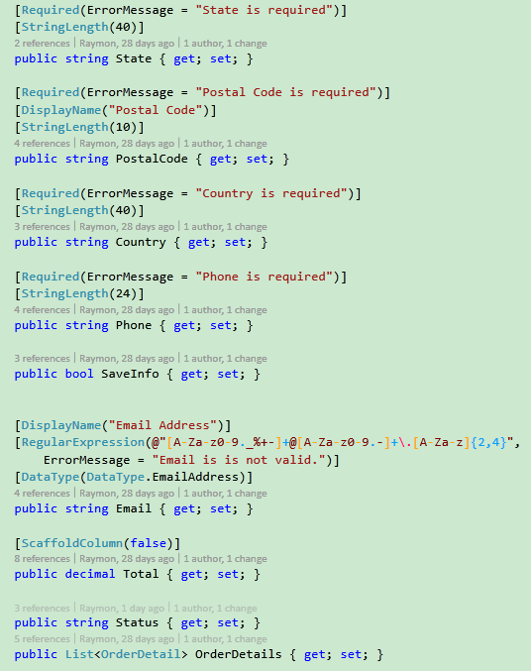

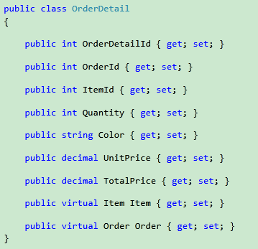

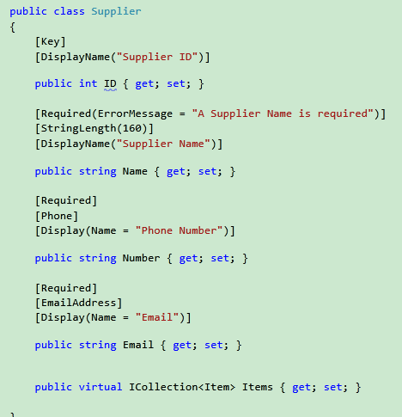

The website uses Microsoft SQL server for its database.

## Relationships

A Cap can have one or more suppliers as well as a supplier can have one or more Caps.

An order can have one or more Caps.

A customer can have one or more orders.

Order items can have one or more Caps.

Cap can have one or more categories.

## ER Diagram

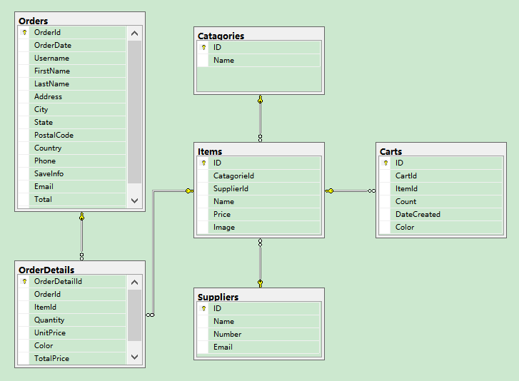

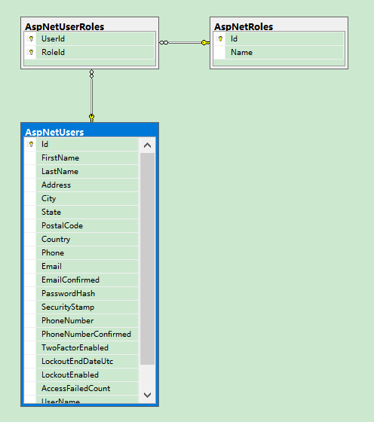

## Technique

Used MVC to build the website

The JavaScript files are stored in the Scripts folder. Also, the bootstrap theme is used to develop the website.

The images are kept in the Images folder.

The CSS files are kept in the content folder.

Entity framework is used to communicate with database due to performance; it is one of the best ways to use which helps in decreasing response time when a page loads without having much to do with the server.

Considering the business layer, controllers are stored in the controller folder.

For the view, all files are stored in Views folder.

# Test Cases

## Any User/New Customer

|  |  |  |  |
| --- | --- | --- | --- |
| **Number** | **Criteria** | **Expected Result** | **Status (Pass/Fail)** |
| 1. | User clicks on Home link or logo | The page should be redirected to the home page (default.aspx) | Pass |
| 2. | User clicks on Caps link from navigation menu | Caps page should open, displaying Caps deals as content and categories on the right side as menu | Pass |
| 3. | User clicks on Contact link from navigation menu | Open up contact us page which displays contact details and contact form | Pass |
| 4. | User clicks on “Product” link from the navigation menu | All Caps from the should be displayed as content on the Product page (coming from the database) | Pass |
| 5. | User clicks on “Men” link from the Caps page | All Caps from the men’s category should be displayed as content on the Caps page (coming from the database) | Pass |
| 6. | User clicks on “Women” link from the Caps page/footer | All Caps from the women’s category should be displayed as content on the Caps page (coming from the database) | Pass |
| 7. | User clicks on “Children’s” link from the Caps page/footer | All Caps from the Children’s category should be displayed as content on the Caps page (coming from the database) | Pass |
| 8. | User searches Caps using the search box (for example searching “test”) – search button must be clicked | The page should display all the name of Caps related to “test” (coming from the database) | Pass |
| 9 | User add a Caps to cart | Cart page should be displayed which lists all the items in the shopping cart | Pass |
| 10. | From the shopping cart table (MyCart.aspx), user clicks on “Clear All” to empty cart | The cart should be cleaned | Pass |
| 11. | From the product page, user clicks add to cart twice | Quantity should be increased by one in the shopping cart | Pass |
| 12. | From the product page, user clicks add to cart after clicks continue | The page is stay in the same place | Pass |
| 13. | From the shopping cart table, user clicks on Checkout button | Prompt for the user to confirm checkout and redirect to login page | Pass |
| 14. | From the login page , user clicks on register link | Registration page opens which displays all the fields and button for registration | Pass |
| 15. | User fills out all the required fields and clicks on the register button | If successful, a message will be displayed for successful registration and an email will be sent to the user which includes the username and password chosen (fields save into the database) | Pass |
| 16. | User does not input all the required fields from the registration page, such as invalid email, incorrect password matching, missing phone number, incorrect phone number etc. | With proper validation, errors message will be displayed which list all the errors that must be correct to proceed to successful registration | Pass |

## Registered Customer

|  |  |  |  |
| --- | --- | --- | --- |
| **Number** | **Criteria** | **Expected Result** | **Status (Pass/Fail)** |
| 1. | User clicks on “login” button from the navigation menu | Opens up the login page, with the username and password textboxes along with the login button | Pass |
| 2. | From the login page, incorrect username and password are used or no username or password are inputted in the textboxes | Due to proper validation, errors messages will be displayed. Login will not be allowed if information do not match that in the database | Pass |
| 3. | From the login page, correct username and password are used | Successful login will show user to My Order link where all information the user and order details will be displayed. Username will be displayed next to the navigation menu to greet the user (Hello “username”) | Pass |
| 4. | On My Order page, after successful login, user select an order number from the drop-down menu of order detail | Depending on the order number, the order details will be displayed; date, status, GST, grand total, Caps, price, quantity, subtotal, total cost and order number | Pass |
| 5. | User adds a Caps to cart and check out after login | Page will be redirected to MyOrder.aspx page, order will be added to that page as well as to the database | Pass |
| 6. | User clicks on “Logout” from the footer | If login, the user will be logout, redirected to the home page | Pass |

## Admin

|  |  |  |  |
| --- | --- | --- | --- |
| **Number** | **Criteria** | **Expected Result** | **Status (Pass/Fail)** |
| 1. | Admin clicks on “Login” from the header | Page displays Admin area to user – same layout | Pass |
| 2. | Admin inputs the wrong username or password or no username or password | Due to proper validation, the system will display an error message if no username or password are inputted. The system checks the database username and password and if wronged, the same error message will be displayed |  |
| 3. | Admin inputs the correct username and password | Page will be redirected to the home page | Pass |
| 4. | Admin clicks on Categories tab from the Admin area | Categories page should be displayed | Pass |
| 5. | Admin clicks on Colors tab from the Admin area | Colors page should be displayed | Pass |
| 6. | Admin clicks on Customer Details tab from the Admin area | Customer page should be displayed | Pass |
| 7. | Admin clicks on Order Details tab from the Admin area | Order page should be displayed | Pass |
| 8. | Admin clicks on User tab from the Admin area | User page should be displayed | Pass |
| 9. | Admin clicks on Role tab from the Admin area | Roles page should be displayed | Pass |
| 10. | From suppliers page, admin clicks on “edit” for a specific supplier | Page redirects to edit suppliers page, displaying all fields in textboxes which can be changed | Pass |
| 11. | From the edit suppliers page, admin clicks on back to list button | Page redirects to the main suppliers page | Pass |
| 12. | From the edit suppliers page, admin changes some fields and clicks save | Database update, prompt the admin that the update was successful and redirects to main suppliers page | Pass |
| 13. | From the suppliers page, admin selects a specific supplier clicks on delete | The specific supplier will be delete from the database and remove from the table. | Pass |
| 14. | From the suppliers page, admin clicks on create button | Page redirects to create suppliers page which consists of textboxes for suppliers | Pass |
| 15. | Admin inputs correct information and clicks save in the create supplier page | Data save into the database, in the suppliers table and system prompt the admin that the operation is successful | Pass |
| 16. | Admin inputs wrong information and clicks save in the create supplier page | Due to proper validation, an error message will be displayed | Pass |
| 17. | From categories page, admin clicks on “edit” for a specific category | Page redirects to edit categories page, displaying all fields in textboxes which can be changed | Pass |
| 18. | From the edit categories page, admin clicks on back to list button | Page redirects to the main categories page | Pass |
| 19. | From the edit categories page, admin changes some fields and clicks save | Database update, prompt the admin that the update was successful and redirects to main categories page | Pass |
| 20. | From the categories page, admin selects a specific category clicks on delete | The specific category will be delete from the database and remove from the table. Successful deletion will be prompted to the admin | Pass |
| 21. | From the categories page, admin clicks on create button | Page redirects to create categories page which consists of textboxes for categories | Pass |
| 22. | Admin inputs correct information and clicks save in the create supplier page | Data save into the database, in the categories table and system prompt the admin that the operation is successful | Pass |
| 23. | Admin inputs wrong information and clicks save in the create categories page | Due to proper validation, an error message will be displayed | Pass |
| 24. | From Caps page, admin clicks on “edit” for a specific Caps | Page redirects to edit Caps page, displaying all fields in textboxes which can be changed | Pass |
| 25. | From the edit Caps page, admin clicks on back to list button | Page redirects to the main Caps page | Pass |
| 26. | From the edit Caps page, admin changes some fields and clicks save | Database update, prompt the admin that the update was successful and redirects to main Caps page | Pass |
| 27. | From the Caps page, admin selects a specific Caps clicks on delete | The specific Caps will be delete from the database and remove from the table. Successful deletion will be prompted to the admin | Pass |
| 28. | From the Caps page, admin clicks on create button | Page redirects to create Caps page which consists of textboxes for Caps | Pass |
| 29. | Admin inputs correct information and clicks save in the create Caps page | Data save into the database, in the Caps table and system prompt the admin that the operation is successful | Pass |
| 30. | Admin inputs wrong information and clicks save in the create Caps page | Due to proper validation, an error message will be displayed | Pass |
| 31. | From User page, admin clicks on “edit” for a specific Customer Detail | Page redirects to edit User Details page, displaying all fields in textboxes which can be changed | Pass |
| 32. | From the edit User Details page, admin clicks on back to list button | Page redirects to the main User Details page | Pass |
| 33. | From the edit User Details page, admin changes some fields and clicks save | Database update, prompt the admin that the update was successful and redirects to main User Details page | Pass |
| 34. | From Order page, admin clicks on “edit” for a specific Order | Page redirects to edit Order page, displaying all fields in textboxes which can be changed | Pass |
| 35. | From the edit Order page, admin clicks on back to list button | Page redirects to the main Order page | Pass |
| 36. | From the edit Order page, admin changes some fields or change status and clicks save | Database update, prompt the admin that the update was successful and redirects to main Order page | Pass |
| 37. | From Contact Us Messages page, admin clicks on “edit” for a specific Contact Us Message | Page redirects to edit Contact Us Messages page, displaying all fields in textboxes which can be changed | Pass |